Chapter 2. Segmenting LANs
This chapter covers the following key topics:
- Why Segment LANs?—
Discusses motivations for segmenting LANs and the disadvantages of not segmenting.
- Segmenting LANS with Repeaters—
Discusses the purpose, benefits, and limitations of repeaters in LANs.
- Segmenting LANS with Bridges—
Discusses how bridges create collision domains and extend networks. As the foundational technology for LAN switches, this section describes the benefits and limitations of bridges.
- Segmenting LANS with Routers—
Discusses how routers create broadcast domains by limiting the distribution of broadcast frames.
- Segmenting LANS with Switches—
Discusses the differences between bridges and switches, and how switches create broadcast domains differently from routers.
As corporations grow, network administrators find themselves deep in frustration. Management wants more users on the network, whereas users want more bandwidth. To further confuse the issue, finances often conflict with the two objectives, effectively limiting options. Although this book cannot help with the last issue, it can help clarify what technology options exist to increase the number of users served while enhancing the available bandwidth in the system. Network engineers building LAN infrastructures can choose from many internetworking devices to extend networks: repeaters, bridges, routers, and switches. Each component serves specific roles and has utility when properly deployed. Engineers often exhibit some confusion about which component to use for various network configurations. A good understanding of how these devices manipulate collision and broadcast domains helps the network engineer to make intelligent choices. Further, by understanding these elements, discussions in later chapters about collision and broadcast domains have a clearer context.
This chapter, therefore, defines broadcast and collision domains and discusses the role of repeaters, bridges, routers, and switches in manipulating the domains. It also describes why network administrators segment LANs, and how these devices facilitate segmentation.

Why Segment LANs?
Network designers often face a need to extend the distance of a network, the number of users on the system, or the bandwidth available to users. From a corporate point of view, this is a good thing, because it might indicate growth. From a network administrator's point of view, this is often a bad thing, implying sleepless nights and no weekends. Even so, how does an administrator keep everyone happy while maintaining personal sanity?
A straightforward technology answer might include the deployment of a higher speed network. If users currently attach to a legacy 10 Mbps network, you could deploy a Fast Ethernet network and provide an immediate tenfold improvement in bandwidth. Changing the network infrastructure in this way means replacing workstation adapter cards with ones capable of 100 Mbps. It also means replacing the hubs to which the stations connect. The new hubs must also support the new network bandwidth. Although effective, a wholesale upgrade might be cost prohibitive.
Segmenting LANs is another approach to provide users additional bandwidth without replacing all user equipment. By segmenting LANs, the administrator breaks a network into smaller portions and connects them with some type of internetworking equipment. Figure 2-1 illustrates a before-and-after situation for segmenting networks.

Figure 2-1 A Network Before and After Segmentation
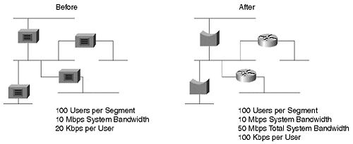
Before segmentation, all 500 users share the network's 10 Mbps bandwidth because the segments interconnect with repeaters. (The next section in this chapter describes how repeaters work and why this is true.) The after network replaces the repeaters with bridges and routers isolating segments and providing more bandwidth for users. Bridges and routers generate bandwidth by creating new collision and broadcast domains as summarized in Table 2-1. (The sections on LAN segmentation with bridges and routers later in this chapter define collision and broadcast domains and describe why this is so.)

Table 2-1. A Comparison of Collision and Broadcast Domain
Device | Collision Domains | Broadcast Domains
Repeater | One | One
Bridge | Many | One
Router | Many | Many
Switch | Many | Configurable
Each segment can further divide with additional bridges, routers, and switches providing even more user bandwidth. By reducing the number of users on each segment, more bandwidth avails itself to users. The extreme case dedicates one user to each segment providing full media bandwidth to each user. This is exactly what switches allow the administrator to build.
The question remains, though, "What should you use to segment the network? Should you use a repeater, bridge, router, or LAN switch?" Repeaters do not really segment a network and do not create more bandwidth. They simply allow you to extend the network distance to some degree. Bridges, routers, and switches are more suitable for LAN segmentation. The sections that follow describe the various options. The repeater is included in the discussion because you might attach a repeater-based network to your segmented network. Therefore, you need to know how repeaters interact with segmentation devices.

Segmenting LANs with Repeaters
Legacy Ethernet systems such as 10Base5, 10Base2, and 10BaseT have distance limitations for segments as described in Chapter 1, "Desktop Technologies." Whenever you desire to extend the distance, you can use an internetworking device like a repeater. Repeaters operate at Layer 1 of the OSI model and appear as an extension to the cable segment. Workstations have no knowledge of the presence of a repeater which is completely transparent to the attached devices. A repeater attaches wire segments together as shown in Figure 2-2.

Figure 2-2 Interconnecting LAN Segments with a Repeater
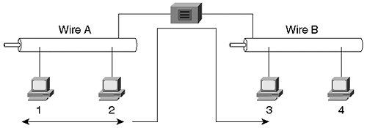
Repeaters regenerate the signal from one wire on to the other. When Station 1 transmits to Station 2, the frame also appears on Wire B, even though the source and destination device coexist on Wire A. Repeaters are unintelligent devices and have no insight to the data content. They blindly perform their responsibility of forwarding signals from one wire to all other wires. If the frame contains errors, the repeater forwards it. If the frame violates the minimum or maximum frame sizes specified by Ethernet, the repeater forwards it. If a collision occurs on Wire A, Wire B also sees it. Repeaters truly act like an extension of the cable.
Although Figure 2-2 shows the interconnection of two segments, repeaters can have many ports to attach multiple segments as shown in Figure 2-3.

Figure 2-3 A Multiport Repeater
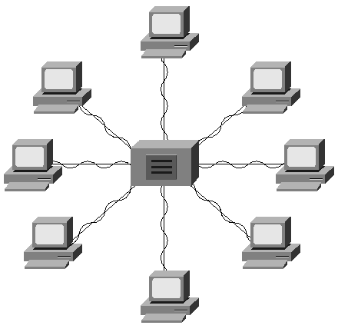
A 10BaseT network is comprised of hubs and twisted-pair cables to interconnect workstations. Hubs are multiport repeaters and forward signals from one interface to all other interfaces. As in Figure 2-2, all stations attached to the hub in Figure 2-3 see all traffic, both the good and the bad.
Repeaters perform several duties associated with signal propagation. For example, repeaters regenerate and retime the signal and create a new preamble. Preamble bits precede the frame destination MAC address and help receivers to synchronize. The 8-byte preamble has an alternating binary 1010 pattern except for the last byte. The last byte of the preamble, which ends in a binary pattern of 10101011, is called the start of frame delimiter (SFD). The last two bits indicate to the receiver that data follows. Repeaters strip all eight preamble bytes from the incoming frame, then generate and prepend a new preamble on the frame before transmission through the outbound interface.
Repeaters also ensure that collisions are signaled on all ports. If Stations 1 and 2 in Figure 2-2 participate in a collision, the collision is enforced through the repeater so that the stations on Wire B also know of the collision. Stations on Wire B must wait for the collision to clear before transmitting. If Stations 3 and 4 do not know of the collision, they might attempt a transmission during Station 1 and 2's collision event. They become additional participants in the collision.
Limitations exist in a repeater-based network. They arise from different causes and must be considered when extending a network with repeaters. The limitations include the following:
- Shared bandwidth between devices
- Specification constraints on the number of stations per segment
- End-to-end distance capability

Shared Bandwidth
A repeater extends not just the distance of the cable, but it also extends the collision domain. Collisions on one segment affect stations on another repeater-connected segment. Collisions extend through a repeater and consume bandwidth on all interconnected segments. Another side effect of a collision domain is the propagation of frames through the network. If the network uses shared network technology, all stations in the repeater-based network share the bandwidth. This is true whether the source frame is unicast, multicast, or broadcast. All stations see all frames. Adding more stations to the repeater network potentially divides the bandwidth even further. Legacy Ethernet systems have a shared 10 Mbps bandwidth. The stations take turns using the bandwidth. As the number of transmitting workstations increases, the amount of available bandwidth decreases.
Note
Bandwidth is actually divided by the number of transmitting stations. Simply attaching a station does not consume bandwidth until the device transmits. As a theoretical extreme, a network can be constructed of 1,000 devices with only one device transmitting and the other 999 only listening. In this case, the bandwidth is dedicated to the single transmitting station by virtue of the fact that no other device is transmitting. Therefore, the transmitter never experiences collisions and can transmit whenever it desires at full media rates.

It behooves the network administrator to determine bandwidth requirements for user applications and to compare them against the theoretical bandwidth available in the network, as well as actual bandwidth available. Use a network analyzer to measure the average and peak bandwidth consumed by the applications. This helps to determine by how much you need to increase the network's capacity to support the applications.

Number of Stations per Segment
Further, Ethernet imposes limits on how many workstations can attach to a cable. These constraints arise from electrical considerations. As the number of transceivers attached to a cable increases, the cable impedance changes and creates electrical reflections in the system. If the impedance changes too much, the collision detection process fails. Limits for legacy systems, for example, include no more than 100 attached devices per segment for a 10Base5 network. A 10Base2 system cannot exceed 30 stations. Repeaters cannot increase the number of stations supported per segment. The limitation is inherent in the bus architectures of 10Base2 and 10Base5 networks.

End-to-End Distance
Another limitation on extending networks with repeaters focuses on distance. An Ethernet link can extend only so far before the media slotTime specified by Ethernet standards is violated. As described in Chapter 1, the slotTime is a function of the network data rate. A 10 Mbps network such as 10BaseT has a slotTime of 51.2 microseconds. A 100 Mbps network slotTime is one tenth that of 10BaseT. The calculated network extent takes into account the slotTime size, latency through various media such as copper and fiber, and the number of repeaters in a network. In a 10 Mbps Ethernet, the number of repeaters in a network must follow the 5/3/1 rule illustrated in Figure 2-4. This rule states that up to five segments can be interconnected with repeaters. But only three of the segments can have devices attached. The other two segments interconnect segments and only allow repeaters to attach at the ends. When following the 5/3/1 rule, an administrator creates one collision domain. A collision in the network propagates through all repeaters to all other segments.

Figure 2-4 Interconnecting with the 5/3/1 Rule
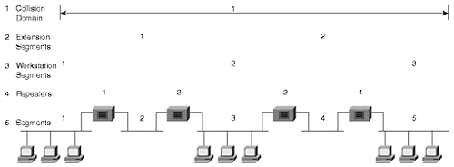
Repeaters, when correctly used, extend the collision domain by interconnecting segments at OSI Layer 1. Any transmission in the collision domain propagates to all other stations in the network. A network administrator must, however, take into account the 5/3/1 rule. If the network needs to extend beyond these limits, other internetworking device types must be used. For example, the administrator could use a bridge or a router.
Repeaters extend the bounds of broadcast and collision domains, but only to the extent allowed by media repeater rules. The maximum geographical extent, constrained by the media slotTime value, defines the collision domain extent. If you extend the collision domain beyond the bounds defined by the media, the network cannot function correctly. In the case of Ethernet, it experiences late collisions if the network extends too far. Late collision events occur whenever a station experiences a collision outside of the 51.2 µs slotTime.
Figure 2-5 illustrates the boundaries of a collision domain defined by the media slotTime. All segments connected together by repeaters belong to the same collision domain. Figure 2-5 also illustrates the boundaries of a broadcast domain in a repeater-based network. Broadcast domains define the extent that a broadcast propagates throughout a network.

Figure 2-5 Broadcast and Collision Domains in a Repeater Network
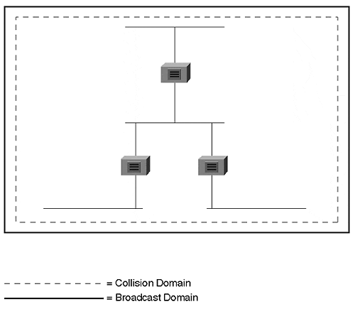
To demonstrate a collision domain, consider IP's Address Resolution Protocol (ARP) process as in Figure 2-6 when IP Station 1 desires to communicate with Station 2. The stations must belong to the same subnetwork as there is no router in the network. Station 1 first ARPs the destination to determine the destination's MAC address. The ARP frame is a broadcast that traverses the entire segment and transparently passes through all repeaters in the network. All stations receive the broadcast and therefore belong to the same broadcast domain. Station 2 sends a unicast reply to Station 1. All stations receive the reply because they all belong to the same collision domain (although it is handled by the NIC hardware as discussed in Chapter 1).

Figure 2-6 ARP Operation in a Repeater Network
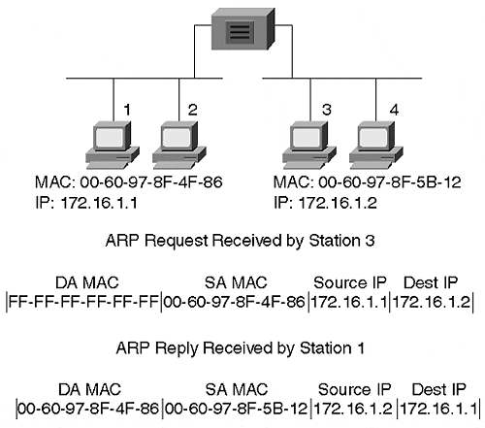

Segmenting LANs with Bridges
As discussed in the previous section, Ethernet rules limit the overall distance a network segment extends and the number of stations attached to a cable segment. What do you do if you need to go further or add more devices? Bridges provide a possible solution. When connecting networks as in Figure 2-7, significant differences exist when compared to repeater-connected networks. For example, whenever stations on the same segment transmit to each other in a repeated network, the frame appears on all other segments in the repeated network. But this does not normally happen in a bridged network. Bridges use a filter process to determine whether or not to forward a frame to other interfaces.

Figure 2-7 Interconnecting Segments with a Bridge
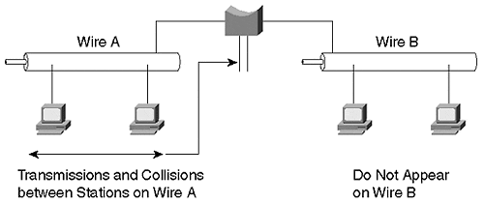
The filter process differs for access methods such as Ethernet and Token Ring. For example, Ethernet employs a process called transparent bridging that examines the destination MAC address and determines if a frame should be forwarded, filtered, or flooded. Bridges operate at Layer 2 of the OSI model, the data link layer. By functioning at this layer, bridges have the capability to examine the MAC headers of frames. They can, therefore, make forwarding decisions based on information in the header such as the MAC address. Token Ring can also use source-route bridging which determines frame flow differently from transparent bridges. These methods, and others, are discussed in more detail in Chapter 3, "Bridging Technologies."
More importantly, though, bridges interconnect collision domains allowing independent collision domains to appear as if they were connected, without propagating collisions between them. Figure 2-8 shows the same network as in Figure 2-5, but with bridges interconnecting the segments. In the repeater-based network, all the segments belong to the same collision domain. The network bandwidth was divided between the four segments. In Figure 2-8, however, each segment belongs to a different collision domain. If this were a 10 Mbps legacy network, each segment would have its own 10 Mbps of bandwidth for a collective bandwidth of 40 Mbps.

Figure 2-8 Bridges Create Multiple Collision Domains and One Broadcast Domain
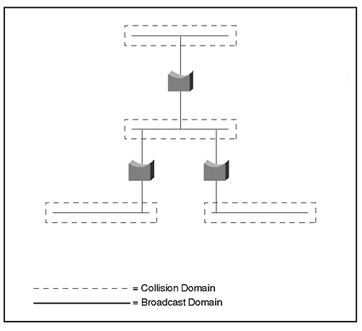
This significant improvement in bandwidth demonstrates why segmenting a LAN benefits users. The same number of users in the network in Figure 2-8 now have more available bandwidth than they did in the network in Figure 2-5. Although switching is discussed later in the chapter, it is valid to comment now that the ultimate bandwidth distribution occurs when you dedicate one user for each bridge interface. Each user then has all of the local bandwidth to himself; only one station and the bridge port belong to the collision domain. This is, in effect, what switching technology does.
Another advantage of bridges stems from their Layer 2 operation. In the repeater-based network, an end-to-end distance limitation prevents the network from extending indefinitely. Bridges allow each segment to extend a full distance. Each segment has its own slotTime value. Bridges do not forward collisions between segments. Rather, bridges isolate collision domains and reestablish slotTimes. Bridges can, in theory, extend networks indefinitely. Practical considerations prevent this, however.
Bridges filter traffic when the source and destination reside on the same interface. Broadcast and multicast frames are the exception to this. Whenever a bridge receives a broadcast or multicast, it floods the broadcast message out all interfaces. Again, consider ARP as in the repeater-based network. When a station in a bridged network wants to communicate with another IP station in the same bridged network, the source sends a broadcast ARP request. The request, a broadcast frame, passes through all bridges and out all bridge interfaces. All segments attached to a bridge belong to the same broadcast domain. Because they belong to the same broadcast domain, all stations should also belong to the same IP subnetwork.
A bridged network can easily become overwhelmed with broadcast and multicast traffic if applications generate this kind of traffic. For example, multimedia applications such as video conferencing over IP networks create multicast traffic. Frames from all participants propagate to every segment. In effect, this reduces the network to appear as one giant shared network. The bandwidth becomes shared bandwidth.
In most networks, the majority of frames are not broadcast frames. Some protocols generate more than others, but the bandwidth consumed by these protocol broadcast frames is a relatively small percentage of the LAN media bandwidth.
When should you use bridges? Are there any advantages of bridges over repeaters? What about stations communicating with unicast frames? How do bridges treat this traffic?
When a source and destination device are on the same interface, the bridge filters the frames and does not forward the traffic to any other interface. (Unless the frame is a broadcast or multicast.) If the source and destination reside on different ports relative to the bridge, the bridge forwards the frame to the appropriate interface to reach the destination. The processes of filtering and selective forwarding preserve bandwidth on other segments. This is a significant advantage of bridges over repeaters that offers no frame discrimination capabilities.
When a bridge forwards traffic, it does not change the frame. Like a repeater, a bridge does nothing more to the frame than to clean up the signal before it sends it to another port. Layer 2 and Layer 3 addresses remain unchanged as frames transit a bridge. In contrast, routers change the Layer 2 address. (This is shown in the following section on routers.)
A rule of thumb when designing networks with bridges is the 80/20 rule. This rule states that bridges are most efficient when 80 percent of the segment traffic is local and only 20 percent needs to cross a bridge to another segment. This rule originated from traditional network design where server resources resided on the same segments with the client devices they served, as in Figure 2-9.

Figure 2-9 The 80/20 Rule Demonstrated in a Traditional Network
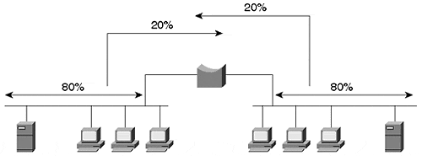
The clients only infrequently needed to access devices on the other side of a bridge. Bridged networks are considered to be well designed when the 80/20 rule is observed. As long as this traffic balance is maintained, each segment in the network appears to have full media bandwidth. If however, the flow balance shifts such that more traffic gets forwarded through the bridge rather than filtered, the network behaves as if all segments operate on the same shared network. The bridge in this case provides nothing more than the capability to daisy-chain collision domains to extend distance, but without any bandwidth improvements.
Consider the worst case for traffic flow in a bridged network: 0/100 where none of the traffic remains local and all sources transmit to destinations on other segments. In the case of a two-port bridge, the entire system has shared bandwidth rather than isolated bandwidth. The bridge only extends the geographical extent of the network and offers no bandwidth gains. Unfortunately, many intranets see similar traffic patterns, with typical ratios of 20/80 rather than 80/20. This results from many users attempting to communicate with and through the Internet. Much of the traffic flows from a local segment to the WAN connection and crosses broadcast domain boundaries. Chapter 14, "Campus Design Models," discusses the current traffic trends and the demise of the 80/20 rule of thumb in modern networks.
One other advantage of bridges is that they prevent errored frames from transiting to another segment. If the bridge sees that a frame has errors or that it violates the media access method size rules, the bridge drops the frame. This protects the destination network from bad frames that do nothing more than consume bandwidth for the destination device discards the frame anyway. Collisions on a shared legacy network often create frame fragments that are sometimes called runt frames. These frames violate the Ethernet minimum frame size rule of 64 bytes. Chapter 3, "Bridging Technologies," shows the frame size rules in Table 3-5. Whereas a repeater forwards runts to the other segments, a bridge blocks them.

Segmenting LANs with Routers
Bridges, operating at a layer higher than repeaters, add functionality to the network, which is not present in repeaters. Bridges perform all repeater functions, and more, by creating new collision domains. Likewise, routers, which operate at Layer 3, add functionality beyond bridges. Routers extend networks like bridges, but they create both collision and broadcast domains. Routers prevent broadcasts from propagating across networks. This broadcast isolation creates individual broadcast domains not found in bridges. The router behavior of blocking broadcast frames defines broadcast domain boundaries—the extent to which a broadcast frame propagates in a network. Figure 2-10 shows a network built with routers and identifies collision and broadcast domains.

Figure 2-10 Broadcast and Collision Domains in a Routed Network
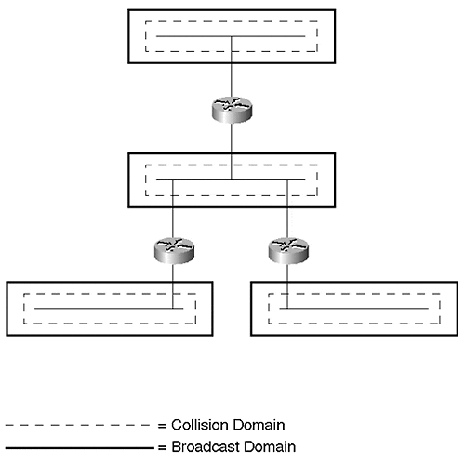
A side effect of separate broadcast domains demonstrates itself in the behavior of routers. In a repeater- or bridge-based network, all stations belong to the same subnetwork because they all belong to the same broadcast domain. In a router-based network, however, which creates multiple broadcast domains, each segment belongs to a different subnetwork. This forces workstations to behave differently than they did in the bridged network. Refer to Figure 2-11 and Table 2-2 for a description of the ARP process in a routed network. Although the world does not need another description of ARP, it does in this case serve to illustrate how frames flow through a router in contrast to bridges and repeaters. Further, it serves as an example of how workstations must behave differently with the presence of a router. In a bridge- or repeater-based network, the workstations transmit as if the source and destination are in the collision domain, even though it is possible in a bridged network for them to be in different domains. The aspect that allows them to behave this way in the bridged network is that they are in the same broadcast domain. However, when they are in different broadcast domains, as with the introduction of a router, the source and destination must be aware of the router and must address their traffic to the router.

Figure 2-11 Frame Header Changes through a Router
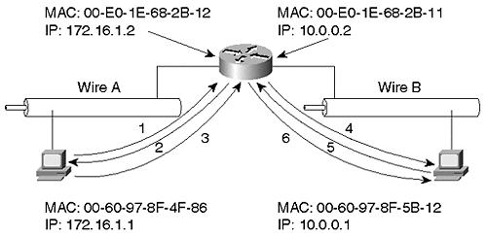

Table 2-2. Frame Exchange in a Routed Network
 | Layer 2 Header (Modified) |  | Layer 3 Header (Unmodified)
Frame | Destination MAC | Source MAC | Source IP | Destination IP
1* | FF-FF-FF-FF-FF-FF | 00-60-97-8F-4F-86 | 172.16.1.1 | 172.16.1.2
2** | 00-60-97-8F-4F-86 | 00-E0-1E-68-2B-12 | 172.16.1.2 | 172.16.1.1
3*** | 00-E0-1E-68-2B-12 | 00-60-97-8F-4F-86 | 172.16.1.1 | 10.0.0.1
4* | FF-FF-FF-FF-FF-FF | 00-E0-1E-68-2B-11 | 10.0.0.2 | 10.0.0.1
5** | 00-E0-1E-68-2B-11 | 00-60-97-8F-5B-12 | 10.0.0.1 | 10.0.0.2
6*** | 00-60-97-8F-5B-12 | 00-E0-1E-68-2B-11 | 172.16.1.1 | 10.0.0.1
*ARP Request
**ARP Reply
***User Data Frame
When Station 1 wants to talk to Station 2, Station 1 realizes that the destination is on a different network by comparing the destination's logical address to its own. Knowing that they are on different networks forces the source to communicate through a router. The router is identified through the default router or default gateway setting on the workstation. To communicate with the router, the source must address the router at Layer 2 using the router's MAC address. To obtain the router's MAC address, the source first ARPs the router (see frames 1 and 2 in Figure 2-11). The source then creates a frame with the router's MAC address as the destination MAC address and with Station 2's logical address for the destination Layer 3 address (see frame 3 in Figure 2-11). When the frame enters the router, the router determines how to get to the destination network. In this example, the destination directly attaches to the router. The router ARPs for Station 2 (frames 4 and 5 in Figure 2-11) and creates a frame with station 2's MAC address for the L2 destination and router's MAC for the L2 source (see frame 6 in Figure 2-11). The router uses L3 addresses for Stations 1 and 2. The data link layer header changes as the frame moves through a router, while the L3 header remains the same.
In contrast, remember that as the frame transits a repeater or bridge, the frame remains the same. Neither repeaters nor bridges modify the frame. Like a bridge, routers prevent errored frames from entering the destination network.

Segmenting LANs with Switches
So far, this chapter reviewed three legacy internetworking devices. These devices interconnected networks and segments together. During the early 1990s, a bridge derivative found a place in the market. Kalpana introduced a LAN switching device, called the EtherSwitch. EtherSwitch was a glorified bridge in that it offered many ports to attach directly to devices rather than to segments. Each port defined a separate collision domain providing maximum media bandwidth for the attached user. Such an innovative application of a well-known technology, bridging, quickly found favor among network administrators. It provided immediate bandwidth increase for users without needing to implement a complete infrastructure renovation. Recognizing the technology value, Cisco Systems purchased Kalpana in December of 1994. This complemented the Catalyst product line acquired in September 1993 from Crescendo Communications. The Catalyst product line consisted of the Catalyst 1200 and, in March of 1995, the Catalyst 5000. Yet another acquisition in September 1995 of Grand Junction Networks further expanded the product line by introducing the Catalyst 1900 and 2820 products. This growing product line deeply penetrated and frontiered the switching market.
What exactly is a LAN switch? A LAN switch is a multiport bridge that allows workstations to attach directly to the switch to experience full media bandwidth and enables many workstations to transmit concurrently. For example, Figure 2-12 shows four workstations communicating at the same time, something impossible in a shared network environment.

Figure 2-12 Multiple Concurrent Sessions through a LAN Switch
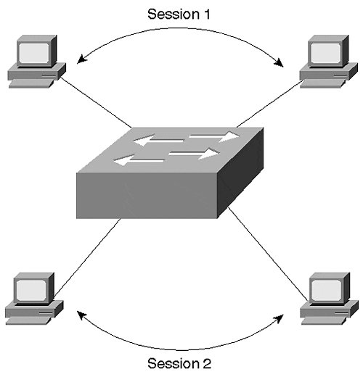
Because a switch is nothing more than a complex bridge with multiple interfaces, all of the ports on a switch belong to one broadcast domain. If Station 1 sends a broadcast frame, all devices attached to the switch receive it. The switch floods broadcast transmissions to all other ports. Unfortunately, this makes the switch no more efficient than a shared media interconnected with repeaters or bridges when dealing with broadcast or multicast frames.
It is possible to design the switch so that ports can belong to different broadcast domains as assigned by a network administrator, thus providing broadcast isolation. In Figure 2-13, some ports belong to Broadcast Domain 1 (BD1), some ports to Broadcast Domain 2 (BD2), and still others to Broadcast Domain 3 (BD3). If a station attached to an interface in BD1 transmits a broadcast frame, the switch forwards the broadcast only to the interfaces belonging to the same domain. The other broadcast domains do not experience any bandwidth consumption resulting from BD1's broadcast. In fact, it is impossible for any frame to cross from one broadcast domain to another without the introduction of another external device, such as a router, to interconnect the domains.

Figure 2-13 A Multibroadcast Domain Capable Switch
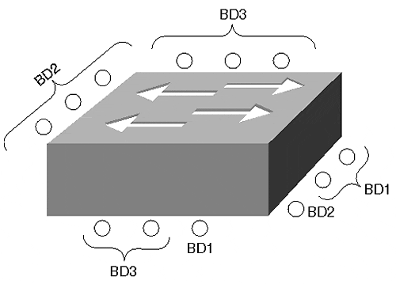
Switches capable of defining multiple broadcast domains actually define virtual LANs (VLANs). Each broadcast domain equates to a VLAN. Chapter 5, "VLANs," discusses VLANs in more detail. For now, think of a VLAN capable switch as a device that creates multiple isolated bridges as shown in Figure 2-14.

Figure 2-14 A Logical Internal Representation of a VLAN Capable Switch
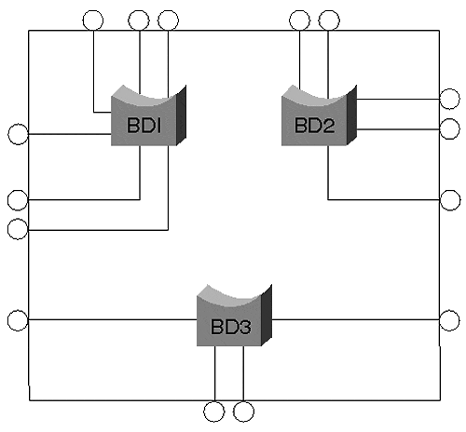
If you create five VLANs, you create five virtual bridge functions within the switch. Each bridge function is logically isolated from the others.

Summary
What is the difference between a bridge and a switch? Marketing. A switch uses bridge technology but positions itself as a device to interconnect individual devices rather than networks. Both devices create collision domains on each port. Both have the potential to create multiple broadcast domains depending upon the vendor implementation and the user configuration.

Review Questions
Refer to the network setup in Figure 2-15 to answer Questions 1 and 2.

Figure 2-15 Graphic for Review Questions 1 and 2
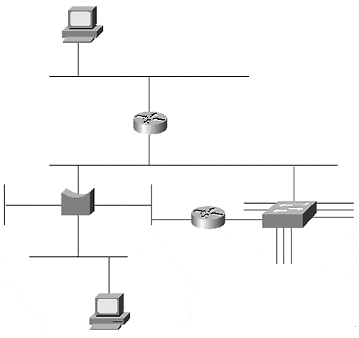
1: | Examine Figure 2-15. How many broadcast and collision domains are there?
2: | In Figure 2-15, how many Layer 2 and Layer 3 address pairs are used to transmit between Stations 1 and 2?  Refer to the network setup in Figure 2-16 to answer Question 3.  Figure 2-16 Graphic for Review Question 3  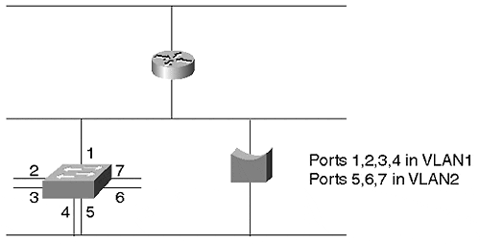
3: | What is the problem with the network in Figure 2-16?
4: | If you attach a multiport repeater (hub) to a bridge port, how many broadcast domains are seen on the hub?
5: | Can a legacy bridge belong to more than one broadcast domain?

